Session 7
1.
Create a table called Orders with columns: order_id, user_name, total_amount, and order_date. Insert 5 sample rows with different users and order amounts, including at least one NULL value for total_amount.
Ans : USE foodie_app;

CREATE TABLE Orders (
order_id INT PRIMARY KEY,
user_name VARCHAR(100),
total_amount DECIMAL(10,2),
order_date DATE
);

INSERT INTO Orders (order_id, user_name, total_amount, order_date)
VALUES
(1, 'Amit', 1200.50, '2026-07-01'),
(2, 'Priya', 850.00, '2026-07-02'),
(3, 'Rahul', NULL, '2026-07-03'),
(4, 'Amit', 1500.00, '2026-07-04'),
(5, 'Neha', 950.75, '2026-07-05');
2.
Write a SQL query to count how many orders were placed by each user in the Orders table, displaying user_name and the number of orders as order_count.
ANS :

SELECT
user_name,
COUNT(order_id) AS order_count
FROM Orders
GROUP BY user_name;

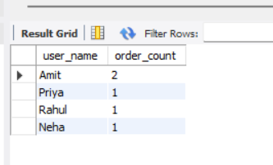
3.
Write a SQL query to calculate the average total_amount of all orders in the Orders table, making sure to ignore any NULL values.
ANS :
SELECT
AVG(total_amount) AS average_order_amount
FROM Orders;
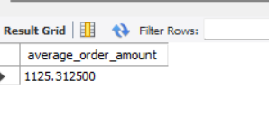

4.
Suppose you are building a Flipkart-style dashboard: Write a SQL query to find the highest and lowest order amounts (MAX and MIN) from the Orders table, and display both values in a single result row.

ANS :
SELECT
MAX(total_amount) AS highest_order,
MIN(total_amount) AS lowest_order
FROM Orders;
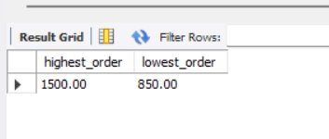

5.
Write a SQL query to calculate the total sales (SUM of total_amount) for all orders, but only include orders where total_amount is not NULL.<br><br><em><strong>Hint:</strong> Use a WHERE clause to filter out NULL values before applying the SUM function.</em>
ANS :
SELECT
SUM(total_amount) AS total_sales
FROM Orders
WHERE total_amount IS NOT NULL;
